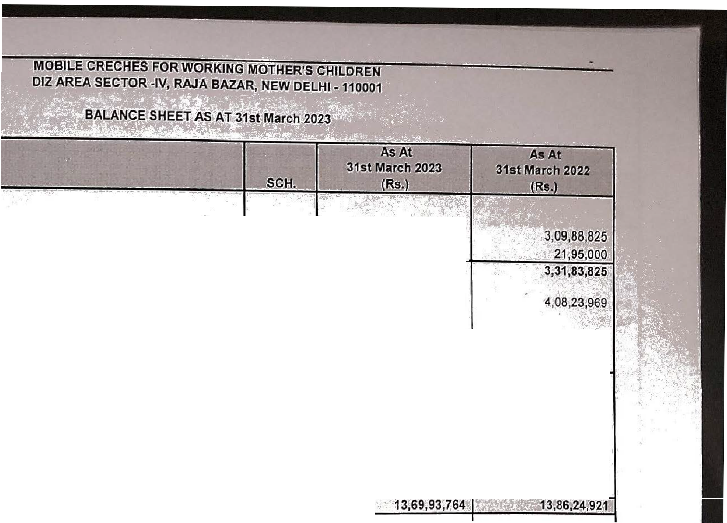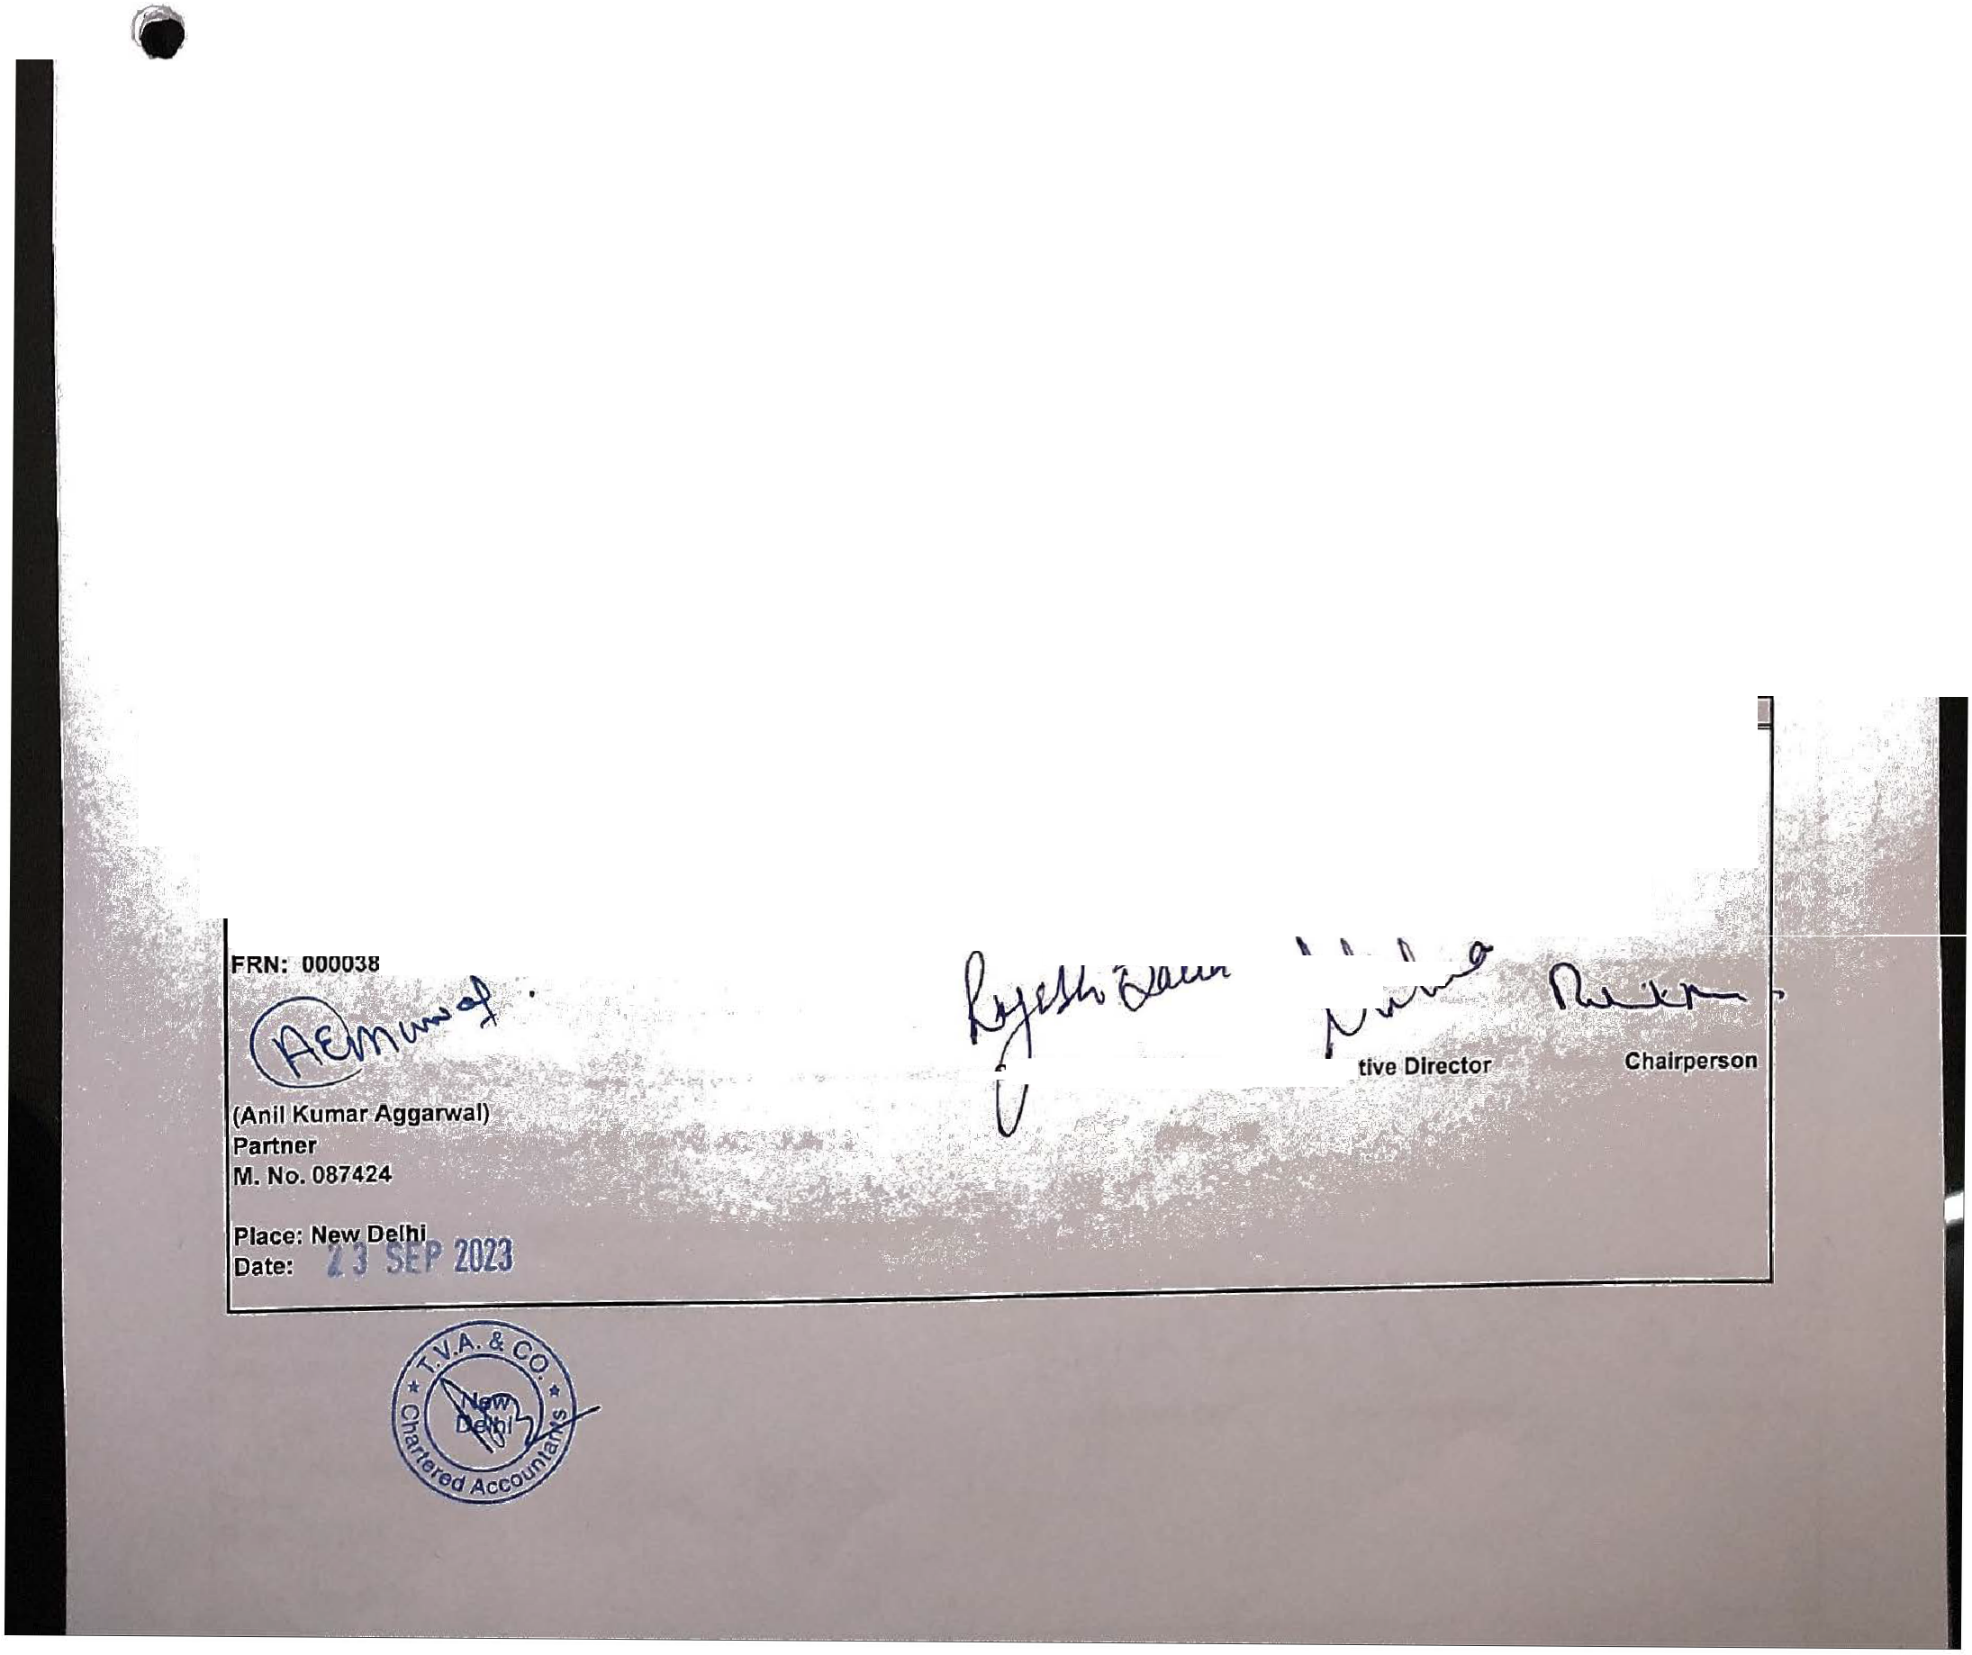

\

* i;uf.lD·s�,; ; ;

,il'���•r -

C::QRPU.S FIJ,Nl!l

3,31,83,825

5,28,000

**3,37,11,825**

4,08,23,969

���t!!,?1��:Ceipts during the year

CQRPU.S FUND· SECTION- 35AC

**GENERAL FUND**

Opening· Balance

Add:-Surplus for the year Trf from Statement of Income and Expenditure

3,54,25,108

10,69,663

**3,64,94,771**

1,01,68,804

2,95,42,865

58,82,2�3

**3,54,25,108**

1,03,73,497

OTHER FUNDS

**GRANTS UNUTILISED**

- Local/Government Grants

-FCRA

**A**

**B-1**

**B-2**

74,35,612

83,58,783

27,79,678

1,60,38,844

APPLICATION OF FUNDS :

FIXED ASSETS

Fixed Assets Funded By Project Grants Fixed Assets Funded By Own Sources

**INVESTMENT**

-Fixed Deposits with Banks

* Fixed Deposits with Financial Institutions

- 8.1% IRFC Bonds(At Cost)

* Mutual Funds(At Lower of Cost or NAV)

**CURRENT ASSETS. LOANS & ADVANCES: CURRENT ASSETS**

Grant Receivable

Cash and Bank Balances Stock-in-Hand

LOANS AND ADVANCES (Unsecured Considered good)

**C-1**

**C-2**

**D**

32,13,760

46,36,449

**78,50,208**

1,96,60,853

6,67,57,000

5,65,000

2,97,93,027

**11,67,75,880**

34,91,772

51,82,964

**86,74,736**

2,39,65,941

6,58,57,000

5,65,000

3,25,91,617

**12,29,79,558**

B-1, B-2 E

45,82,965

1,04,76,244

24,02,045

1,67,17,703

3,41,78,957

2,18,11,281

**1,23,67,676**

2,79,655

31,70,756

32,94,623

1,74,62,538

2,42,07,572

1,72,36,945

**69,70,627**

**t�.8:�21,112;1**

**F**

* ACCOUNTING POLICIES AND NOTES TO ACCOUNTS

LESS:

**G**

CURRENT LIABILITIES AND PROVISIONS

NET CURRENT ASSETS

**rt 3f6.9193,7l6.!I**

Sch. -M

**AS PER OUR SEPARATE REPORT OF EVEN DATE ATTACHED**

:-,i

.

ForMobile Creches For WorkingMother's Children

**F.or Thals.ur, Vaidyanath Aiyar** & **Co.**

*r.*

**C**' .**li**•,**ar;t**-**ered �cco,unta**• **nts**

-

'.

1:1;

•;._·-

.

�-

h.f F,inance Officer� :"'. iLExec;u

.